Dinner Invitation

«MyName»  «MyAddress1»  «MyAddress2»  January 7, 2010  «ContactName»  «ContactTitle»  «CompanyName»  «Address1»  «Address2» | 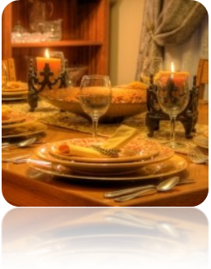

Dear «ContactName»:
You are cordially and secretly invited to a formal dinner in honor of Barry Potter on July 21, 2010, at 8 p.m. at the Alpine Ski House.
As you are an associate of Mr. Potter, we would like you to speak briefly about his work in the lumber industry. If this is possible, please let me know within the next week.
Please note that this is a black-tie event. RSVP with the names of those attending by July 14.
Sincerely,
 | «MyName»  «MyTitle»

